Last Updated: 08/18/2021
This QRG outlines the lateral reclassification with or without a pay change process for an employee in SuccessFactors.

Contents
What is a Lateral Reclassification Request? 1
Lateral Reclassification Process 1
Access SuccessFactors 1
Searching for an Employee 2
Taking Action 3
Processing a Reclassification 5

What is a Lateral Reclassification Request?
A Lateral Reclassification is a change to the employee’s position tile, job classification, and sometimes, pay.
This is process is used when an employee is remaining in their position and the position is changed to a job within the same career stream level (i.e. P2 to P2).

Lateral Reclassification Process
The Initiator processes the reclassification request. Once complete, it is routed for approval to the Department Head and Budget Approver and HR Compensation Team.

Access SuccessFactors
Visit OneCampus and select Employee Launchpad or from the Employee Self-Service web page click SuccessFactors  Log in using Purdue Career Account ID and Password. | https://one.purdue.edu/    https://www.purdue.edu/hr/global/pgnew.php  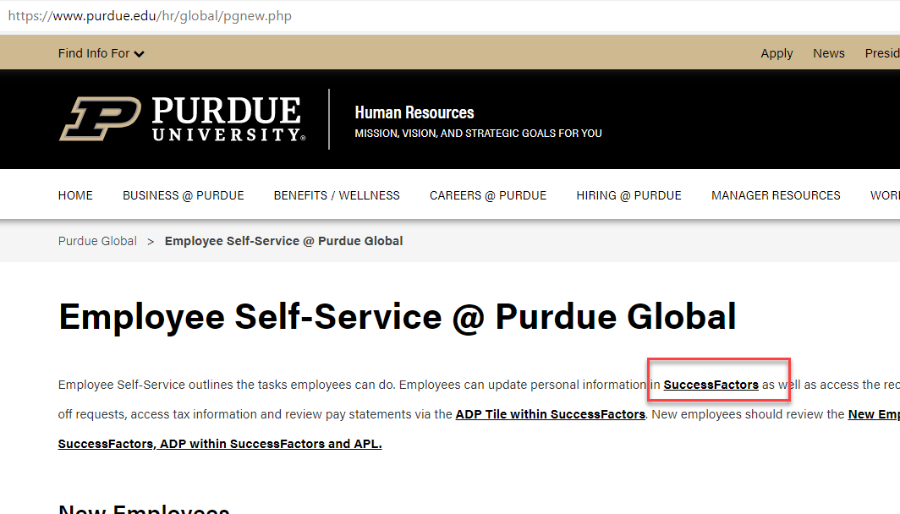

Searching for an Employee
- From the SuccessFactors home page, locate the Search field on the navigation bar.
- In the Search field, type the employee’s name.
- Multiple matches may be displayed.
- Scroll to select the correct name, click to select.
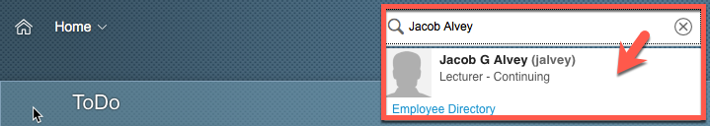
This will display the employee’s Employee File. | 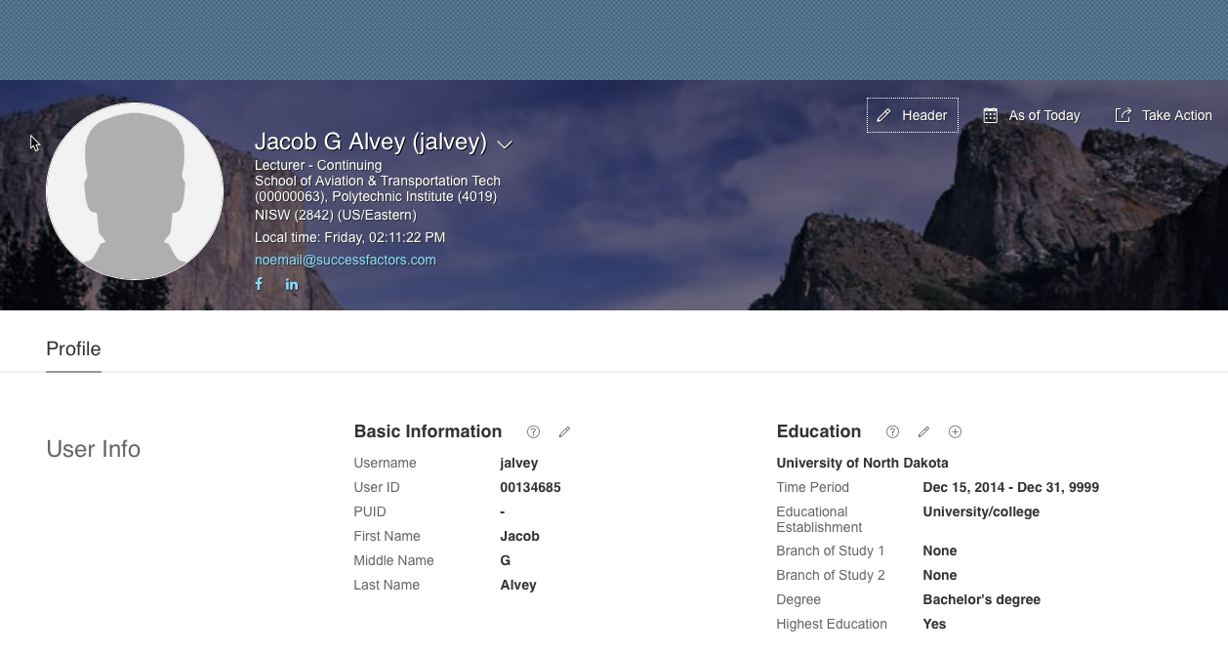

Taking Action
There are two options available to begin processing a Lateral Reclassification.  The first option is found on the SuccessFactors home page.  Once the employee has been located, hover over their name to view their employee information on a separate pop up window.  Next, click Take Action to display action options. | 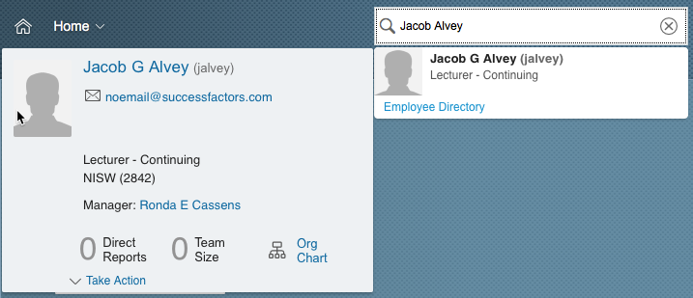
Once the action options are  displayed, select Change Job and Compensation Info to begin processing. | 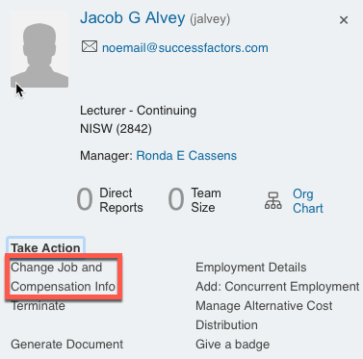
The second option is found on the employee’s Employee Profile.  Click Take Action to display action options. | 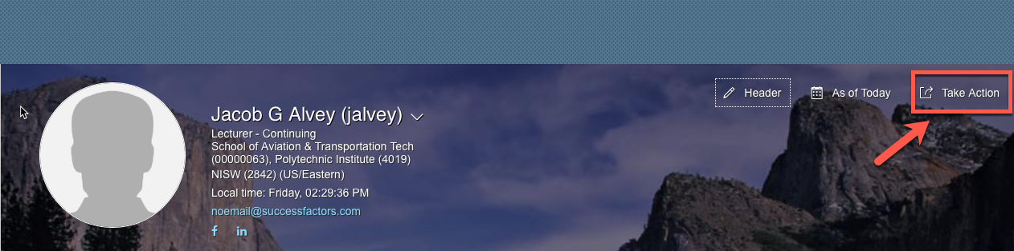
Once the action options are displayed, select Change Job and Compensation Info. | 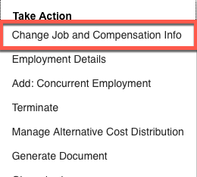

Processing a Reclassification
Click the check boxes next to both Job Information and Compensation Information to select.  Next, manually input the date (mm/dd/yy) the job change should take effect or click the Calendar icon to display a calendar.  Click the day the job change should take effect to populate the date field. | 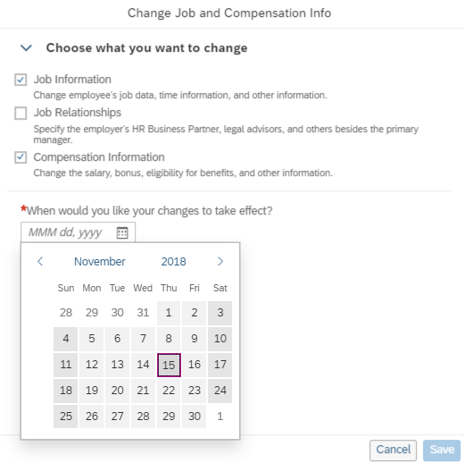
Once the date field has been populated, the field options associated with all selected change types are displayed. | 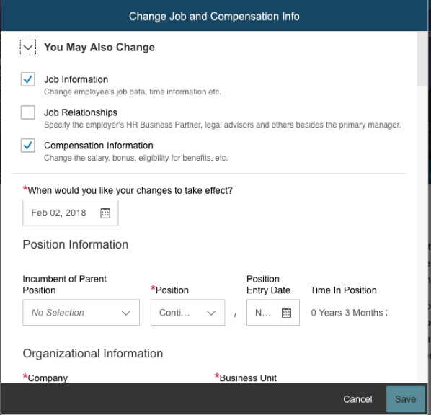
Scroll down to the to the Job Information header.  - Change the Position Title  - Change the Job Classification  All other information necessary will auto-populate based on the selections made.  Note: Once a field has been re-populated, the previous entry is displayed below with a strike through. | 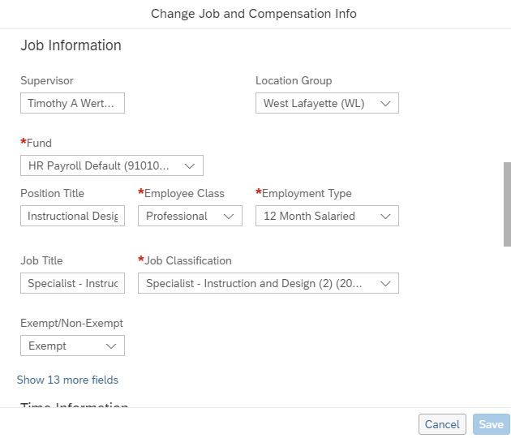
If a Pay Change is NOT needed, click Save to submit the request and move to next page of this QRG.
Scroll down to the Compensation header.
- Click the dropdown arrow in the Pay Component field. Reselect the existing pay component.
  - Completing this step updates the fields associated with the pay component selection, including Frequency (based on the Employment Type selected in the step above.)
- Enter the new Amount.
  - Alternatively, use the calculator feature to change the current amount by a specific percentage.
    - Click the Calculator icon to display the Change Calculator box.
    - Type either the value of the change in the Change Amount field or the percentage of the change in the Change Percent field.
    - The Total Amount field will be auto-populated.
    - Click Save on the Change Calculator box and then click
Save on the Change Job and Compensation Info box.
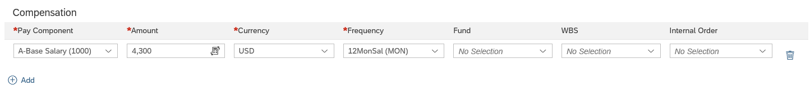
The Confirmation Request box is displayed.
- Enter any comments to be shared with other workflow participants in the comment box.
- Click Confirm.
- Note: Click Show workflow participants to display the names of the individuals responsible for the review and approval process. Note: A notification will be sent to the approver(s).
